PROCLAMATION
Borough of Red Bank

WHEREAS, the former Stonewall Inn in New York City, a public establishment frequented by members of the gay community, was the site of the June 27, 1969 uprising that sparked the Lesbian, Gay, Bisexual, Transgender civil rights movement; and
WHEREAS, the Borough of Red Bank fosters the value and importance of diversity among its citizens and its employees acknowledging that they cut across ethnic, cultural, racial, gender identity and sexual orientation boundaries; and
WHEREAS, the Borough of Red Bank celebrates and recognizes the many accomplishments and contribution s of its citizens and employees who identify themselves as members of the Lesbian, Gay, Bisexual and Transgender (LGBT) community; and
WHEREAS, in 1993, New Jersey became the fifth state in the United States to ban discrimination based on sexual orientation; and
WHEREAS, on December 21, 2006, Governor Jon Corzine signed legislation granting gay couples statutory rights of married couples making New Jersey the third state to do so; and
WHEREAS, in 2007 New Jersey became the ninth state in the United States to ban discrimination based on gender identity and expression; and
WHEREAS, on October 21, 2013, New Jersey became the 14th state to allow same sex marriage and the first to do so in the wake of the landmark U.S. Supreme Court decision that struck down the Defense of Marriage Act; and
WHEREAS, The Borough of Red Bank has taken measures to prohibit discriminatory policies and practices based on sexual orientation and identity in the areas of employment, housing and public accommodation including the adoption of a resolution in support of EQUALITY AND CIVIL RIGHTS FOR LESBIAN, GAY, BISEXUAL AND TRANSGENDER AMERICANS in July of 2009;
WHEREAS, I, Pasquale Menna, Mayor of the Borough of Red Bank, do hereby proclaim the month of June 2020 as lesbian, gay, bisexual and transgender pride month in the Borough of Red Bank and we ask our citizens to join us in celebrating.
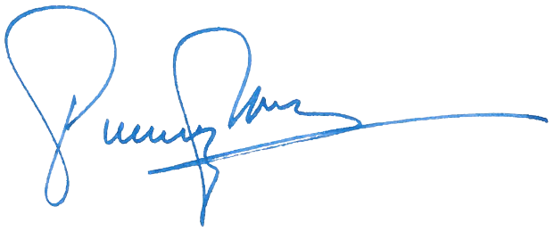

________________________________
PASQUALE MENNA
Mayor

