RE-EXAMINATION REPORT OF THE MASTER PLAN PLANNING AND DEVELOPMENT REGULATIONS
OF THE BOROUGH OF RED BANK

INTRODUCTION

ID accordance with the Municipal Land Use Law (NJSA 40:55D-89), the Master Plan must be re-examined every six years. The 1995 Master Plan was re-exami ned in 2002 and 2008 in accordance with the statue.

Following the adoption of the re-examination on Decem ber 15, 2008, the Borough of Red Bank Mayor and Council received requests from residents for an additional public meeting to further discuss the 2008 re-examinati on rep01i. As a result of the public request, an additional public meeting was held on February 18; 2009 to discuss the 2008 reexamination report. This document has been amended to reflect the Board's conclusion as a result of the Febrnary 18, 2009 public meeting and Board discussion.

I. Ma jor land development problems identified in the 2002 Re-Examination Report.

The 2002 Re-Examination Report found significant progress was made in achieving the goals outlined in the 1995 Master Plan. The 2002 Re­ Examination Report indicated residential development increased throughout the Borough; that additional parking had been developed in the Dmvntown area and at the train station, and that occupancy in the Downtown Business District and the Shrewsbury Avenue Business District had dramatic.ally increased since the 1995 Master Plan, The 2002 Report goes on to state that

the number and quality of retai l, financial, restaurant and service occupancies continues to develop and thrive, · and that Red Bank had developed into a destination where shopper activity thrives at all times and that Red Bank had established itself as a place to shop, dine, and enjoy.

The 2002 Re-Examination Report further indicated that business development in the vicinity of the train station/Shrewsbury Avenue area was steadily improving. Many applications for development and occupancy were at both the Planning and Zoning boards in 2002, and sites in the area which were in disrepair for years had been or were being planned for re­ development. The report found that a sense of piide and place was developing in Red Bank store owners, tenants, and residents and stated that a "truly remarkable transformation" had occurred in Red Bank since the 1995 Plan.

The 2002 Rep01i also found that some of the changes since the 1995 Plan resulted in increased pressure on several problems identified in the 1995 Master Plan, primarily parking and traffic circulation, and therefore, the 2002 Re-Examination Repo1i identified additional stress on roadways and traffic congestion as a problem. It also stated that the cost of land, home , office, and rental prices continued to increase with some residents and business owners expressing affordability as an issue.

The 2002 Report found that additional stress on the community was caused by regional facilities such as the YMCA, Armory Ice Rink, and the many service and religious organizations that increase traffic and, in some cases,

not providing tax revenue. The 2002 Re-Examination Repo1t found that the remaini ng developable parcels in the Borough provided unique design challenges and that increased development since the 1995 Master Plan resulted in some loss of street trees and open space which impacts green space.

- Land development objectives that existed in 2002.

The 2002 Re-Examination Report found that the objectives of the 1995 Master Plan continued to be essentially the same objectives in 2002. There was general "satisfaction" that the development and transformation which occurred between 1995 and 2002 was consistent with the goal of the 1995 Plan and was desirable. The 2002 Re-Examination went on to find that there should be a heightened emphasis on providing adequate parking and improved traffic flow in the Borough .

Changes in land development objectives identified in the 2002 Rep01i included a recommendation that the Planning and Zoning boards focus on requiring Board applications provide a look consistent with Red Bank character, and suggested providing an extended mixed-use development between Broad Street and the train station along Monmouth Street. Other objectives in the 2002 Report included reducing noise and providing improved waterfront access tlu·oughout the Borough, and to review standards for residential density in zones west of Maple Avenue to promote development more in keeping with a residentiar character.

Ill. The change in land development problems since the 2002 Re-Examination Rep01i.

Generally, development which has occuned since the 2002 Re-Examination Rep01i has been consistent with the 1995 Master Plan and the 2002 Re­ Examination Rep01i. Additional development has occuned in the Monmouth Street C01Tidor between Broad Street and Shrewsbury Avenue. The River Center Special Improvement District was extended along Monmouth Street to Shrewsbury Avenue. New mixed-use developments have been approved along that corridor that include commercial, retail, and residential components. Additionally, the number and quality of retail, financial, restaurant and other uses continue to develop and thrive. Red Bank continues its role as a regional destination for both shopper, restaurant, and entertainment activities.

Development in the train station area continues to improve since the 2002 Report. Applications have been approved in the train station vicinity have an increased residential density, as well as include retail/commercial components. Applications in the vicinity of the train station for adaptive reuse, as well as demolition and reconstruction have also been approved.

The 2002 Re-Examination Report identified insufficient parking as a continued problem. Since the 2002 Re-Examination Report, the boards have generally not approved applications that proposed new square footage that did not also include sufficient parking. This has caused the positi ve result that applications now include parking garages, underground parking

facilities, and surface parking sufficient to meet the parking demand created by the application. Ordinance changes adopted by the Planning Board and Mayor and Council since the 2002 Re-Examination have reduced the density of residential uses immediately adjacent to the river and reduced densities of residential areas on the west side of town by eliminating attached single­ family and multi-family dwelling uses.

  - The chan ges in land development objectives since the 2002 Re-Examination Report.

The changes in land development objectives since the 2002 Re-Examination include extension of the special improvement district along Monmouth Street to Shrewsbury Avenue and an increase of allowable densities along that co1Tidor. These objectives also include an increase to residential densities in the vicinity of the train station beyond what is provided for in the current ordinance. This change should encourage residential development that ·would predominantly use public transp01iation as the primary means of travel. Additionally, the board recognizes that the current limitations for residential units above retail and commercial (now 4 units/building) as being too restrictive and recommend increased density for these units be considered in the CCD-1, CCD-2 and BR-1 and BR-2 Zones.

In the CCD-1 and CCD-2 Zones, concem was expressed by the Planning Board that the lack of a density requirement in the zone is resulting in applications with excessive densities. Density limits should be considered for the CCD-1 and CCD-2 Zones. It further recognized that "Commercial

Parking Garage" should be a permitted accessory and principal use in the BR-1 and BR-2 zones to allow rental of garage space to help address the parking shmifall in Red Bank.

The Planning Board, Mayor and Council continue to address the shortfall of low and moderate income housing within the Borough as defined by COAH. The Affordable Housing Overlay District was established in the area east of Bridge Avenue which allows an increased density of residential units. The Borough is also preparing a housing plan to address its third round housing allocation for the period 2004 to 2018.

As previously stated, the 2002 Re-Examination Report found that increased development has resulted in loss of street trees and open space. To address this issue, the Borough completed a Community Forestry Management Plan . in 2006 in cooperation with the Red Bank Shade Tree Committee. It is the goal of the Borough of Red Bank to maintain and promote a healthy, safe and sustainable shade tree resource that will physically, economically and aesthetically benefit the community and its residents in the most cost effective manner possible . .

In addition, the Planning Board and Mayor and Council recently adopted expanded limits to the Historic District in the BR-1 and RB-2. Zones in the vicinity of Washington and Front Street to preserve the historic character of that neighborhood. The historic inventory of significant sites in Red Banl< maintained by the Borough Historic Preservation Commission was used to establish the limits of a new Historic Residential District.

Finally, the Board recognized the need for additional waterfront access. The foot of Maple Avenue and the property at the foot of Sunset Avenue were discussed as possi ble candidates for consideration. Additional waterfront properties are discussed in the Red Bank Waterfront Plan which was completed in 2006.

  - The significant changes in Master Plan assmnption policy and objectives.

The policy of objectives of the 1995 Master Plan as modified by the 2002 Re-Examination Report are still considered appropriate for the foreseeable future.

- The significant changes in development regulations assumption policv and objectives.

Since adoption of the 1995 Master Plan and 2002 Re-Examination Report, the Planning and Development Regulations were revised to reflect the addition of new zones and deletion of several others. The zone ordinance was rviewed and revisions made to comply with recommendations of the 1995 Plan and 2002 Re-Examination Report.

Below is a summary of significant amendments to the Planning and
·Development Regulations adopted by the Mayor and Council between 2006 and 2008. The Re-examination committee reviewed the amendments listed

below and re-affirmed the adopted Ordinances are consistent with the goals of the Master Plan:

  - The minimum lot area for lots abutting the Navesink River was increased from 5,000 SF to 30,000 SF in the WD and RD Zones, and from 6,500 SF to 40,000 SF in the RA Zone. (Ordinance No. 2007-1 5)
  - Attached single-family dwellings are no longer a permitted use in the RD and RB-1 Zones. (Ordinance No. 2007-15 and 25)
  - Exterior balconies, decks, and porches shall not be included in
calculations of Floor Area Ratio. (Ordinance No. 2006-52)
  - The Affordable Housing Overlay Zone was created. (Ordinance No. 2006-53)
  - The bulk standards for the RB-1 Zone were revised. (Ordinance No. 2007-25)

- The changes recommended to the Master Plan or the need for a new plan.

The objectives of the 1995 Master Plan are considered valid today. The 2002 Re-Examination Report also confirmed those findings in 2002.

Although the Master Plan remains valid, some changes are required to the Development Regulations to create development that is more consistent (in ce11ain areas of the town) with the Master Plan goals.

- The changes recommended to the Development Regul ations.

The follO\ving is a list of areas in the Planning Development Regulati ons that should be mod ified:

  - According to the Borough Attorney, there may be an issue concerning whether proper notice was given to property owners in affected zones with respect to Ordinance Nos. 2006-52, 2006-53, 2007-15, and 2007-
25. The referenced Ordinances are summarized in Section VI of this document. Therefore the Committee recommends, out of an abundance of caution, that the above noted Ordinances be re-adopted.

- The Re-examination Committee suggests the following modifications for the CCD-1 and CCD-2 zones:
  - For new structures, the permitted uses shall include dwelling apartments on floors above street level at a maximum density of 25 units per acre where adequate parking is provided.
  - For existing structures, the maximum density pen11itted shall be
25 units per acre. However, the permitted maximum density may be increased to allow up to four (4) units per site.
  - The Committee recommends the maximum floor area ratio be reduced from 2.25 to 1.70.
  - Finally, the Committee suggests the maximum height of new structures be reduced from fifty (50 ') feet to forty (40') feet.

- A new zone (or overlay district) should be considered in the vicinity of the train station to encourage residential development with ready

access to public transp01iation as the primary means of travel. A paiiial zone map is attached which shows the boundaries of this overlay district. The Re-examination Committee suggests the following density and height for the overlay district:
  - Maximum density permitted at 35 units per acre. However, the permitted maximum density may be increased to allow· up to four
(4) residential units per site when the rate of 35 units/acre results in less than 4 units.
  - The maximum structure height is rec01mnended to be fifty (50 ') feet.

- The setback requirements in the CCD-1 and CCD-2, BR-1 and BR-2 Zones should be reviewed and revised. Generally, applications in these zones are not compliant with the bulk requirements. However, the number of variances for set back given in these zones indicates the standards should be adjusted.

- The Active recreation requirement for multi-family dwellings is cunently 250 square feet per unit. The Committee suggests reviewing this requirement. In addition, the ordinance requiring a payment in lieu of providing active recreation should be reconsidered.

- The Plaiming Board evaluated the parking fee required in the ordinance (Zones HB, CCD-1, CCD-2, BR-1, BR-2 PO, WD, MS, I, and LI) and concludes the parking fee requirement to be absolutely mandatory and reaffirms its validity.

- Side yard setback should be modified in all residential zones to allow air-conditioning units to be no closer than 3 feet from the prope1iy line, provided that unit is compliant with applicable noise ordinances and is screened from neigh bor view.

- The density requirements m the BR-1 and BR-2 zones shall be increased to encourage increased residential development in that area and to allow residential uses above retail consistent with the recent extension of the River Center District. The maximum density permitted shall be 16 units per acre. However, the permitted maximum density may be increased to allow up to 4 units per site.

- The parking requirement for primary food and primary liquor should be changed from based on "maximum-rated occupancy" to an amount based on a "building-square-footage".

- The new Historic District on Washington Street should be added to the Zoning Map.

- Change the requirement for office, professional office and medical offi ce parking to 5 spaces per 1,000 square feet.

- Establish a height limitation of 35 feet and 2.5 stories for single-family uses in the BR-1 and BR-2 Zones.

- Lim it the permitted uses along Rector Place m the WD Zone to detached single-famil y dwellings.

- Clarify the definition of "primary food service" such that any use which serves prepared food is considered a "primary food service".

- Clarify the definition of "apaiiment house", "garden apartment" and "townhouse dwelling" as structures used only for residential purposes.

- The definition of "vertical parking garage" is unclear and should be modified and listed as a pennitted use in the BR-1 and BR-2 Zones. In addition, "Commercial Parking Garage" should be listed as a permitted accessory and principal use in the BR-1 and BR-2 Zones.

- The definition of Commercial Recreation Facility should .be clarified to include both profit and non-profit establishments.

- Remove "lodges, clubs, and fraternal organizations" from the list of permitted uses in the PO and NB Zones.

- Based on the current zoning ordinance, a change of occupancy of a retail establishment to personal service (i.e. nail/hair salon, tanning salon, yoga/dance studio, Pil.ates studio, etc.), triggers a need for Planning Board approval for the change of use, even though the proposed occupancy may be permitted in the zone. This resul ts from an ordinance requirement where a proposed occupancy moves from

one use to a use lovver in th e "list of uses" and is then considered a "change in use" requiring Board approval. In many instances, this process is for minor changes which create a cost to downtown business owners who are moving into and want to occupy existing sites. The Board rec01ru11ends an ordinance change that would streamline the approval process for "minor changes" to occupancies in the CCD-1 and CCD-2 Zone and will reduce the load on the Planning Board for applications which are minor in nature.

- The Board recommends a rev1s10n to the Ordinance which would allow the Administrative Officer to approve a change from one permitted use to another permitted use when no new gross floor area or variances are proposed and the increase in parking demand is less than 5 spaces. Applications that meet the criteria for administrative approval would still be required to pay all applicable fees, including COAH, utility fees, and parking fees, as appropriate. This recommendation does not apply to primary food and primary liquor­ type uses since these uses have delivery and trash issues which should be reviewed by the Board.

- The Board supp01is the Borough's interest in "green" Ordinances which will provide incentives to Developers to include green technologies in new building projects.
H:\RBNK\02180\Calculatiort & Reports\Red Bank Re-Exmnination Report_030209.doc

. '

-------------·---;--·------..----=-------------.------------------. ----:--·--.----·--c---.--------. -----··----------------·--,........,.,.
:£

------------ -------------,.q---D-------0----I --IV--;--,-V --G-----N----p
--I---------------

I
!/
I

/ £. . :

,,

TRAIN STATION
1\\\ "]
OVERLAY DISTRICT
0

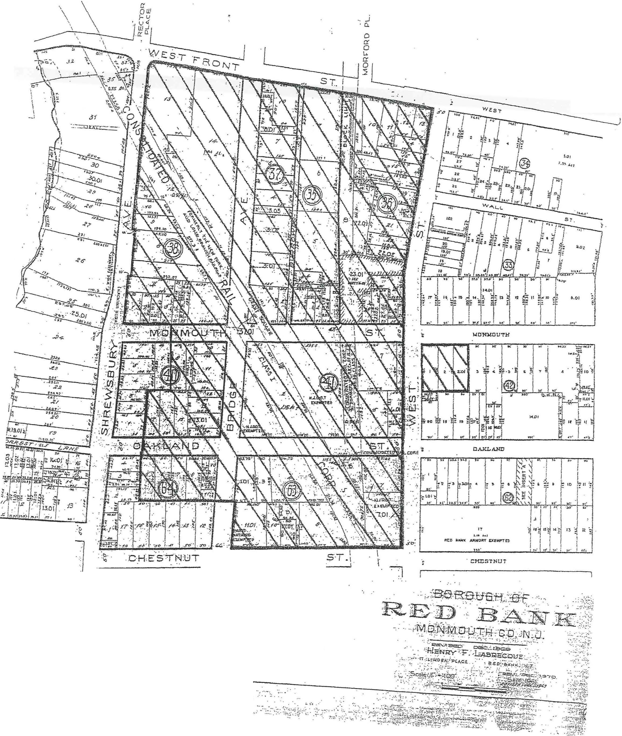·· - - 1-·/(
.. .

';":i·.·- -·; .•

. ..;. _

